**ACTIVITY : CERTIFICATION & INSPECTION OF CUTTING SETS, TROLLEYS, SAFETY BELT , AIR RECIEVER , EOT CRANES ,LIFTING TOOLS & LADDERS (Safe use ladders as well)**

**Objective :-**Certification & Inspection for safe working

**Scope :-**Blast furnace 1 & 2

**Ref :-**

**Responsibility :-** Engineer In charge and workmen at the job, Contractors

**PPEs to be used:** Helmet, Safety shoes, hand gloves

* **Work No 1 :** Certification of cutting sets
* **Work No:2 :** Certification of trolley
* **Work No:3 :** Certification of safety belt
* **Work N:4 :** Certification & Inspection of Air receivers in the plant
* **Work No:5 :** Certification of Lifting tools TESTING/CHECKING
* **Work No:6 :** SAFETY, CERTIFICATION AND INSPECTION OF LADDER FOR SAFE WORKING

**Aspect- Impact**

|  |  |
| --- | --- |
| Scrap generation | Resource Depletion |

**Hazards id****entified**

**Mechanical Hazard** -

* Fall of cylinders, regulator, torches, trolley etc.
* Tripping
* Non use of PPE’s while carrying out the activity
* Trapping between objects
* Impact
* Falling of material from height
* Falling of person from height

**Human behavior:**

* Non usage of PPE’s
* Person working under the influence of alcohol.
* Person by passing work instruction.
* Horseplay

**Physical Hazard:**

* Chemical hazard: Co gas poisoning

**Electrical:**

* Shock

**Work No 1 : Certification of cutting sets**

**General guidelines for certification of cutting sets**

* All cutting set hoses (Both Oxygen and LPG) must be 25 meter in length. However one joint each is allowed on each hose properly clamped with “Jublic" clamps.
* Both oxygen and LPG cylinder hoses must be tied together at 2 m each length.
* Cutting set hoses should not have any cuts on the hoses and should be in good condition.
* Cutting set should be provided with working regulator with double gauges and flash back arrestor on both oxygen and LPG line.
* Two flash back arrestors must be present for the nozzles for both oxygen and LPG line.
* Cutting set nozzles should be of good condition (Nozzle holes not enlarged) and with proper knob for adjusting the flow.

**Procedure for cutting set inspection.**

1. Carry out certification and inspection of the cutting set as per the general guidelines given above.
2. Check for any leakages in the cutting set and check for proper functioning of the gauges, torch etc.
3. Certify the cutting set by sticking new label with renewed dates if the cutting set is as per our requirements and duly signed by the engineer in-charge.
4. If the cutting set is not as per requirement, request the concerned to remove the cutting set from the service until the same is complied with safety requirements and duly certified.
5. Inspection to be carried out at every 2-month.
6. The responsibility of rectifying any problems found in the cutting set rests on the user.
7. Register to be maintained with status of cutting sets certified.

**Work No: 2 : Certification of trolley**

1. Visually check the structural work for strength and should painted.
2. Check the condition of the wheel and brake of the cylinder trolley for good condition.
3. User should ensure the availability of identification number for each trolley.
4. Check the lock chain for cylinder for proper fitting by fixing the cylinder. Take proper care to avoid fall of cylinder while handling.

**Work No: 3 : Certification of safety belt/Harness**

1. Check the belt/harness lock for good locking.
2. Check the hanging lock at the belt for any damage.
3. No external damage is allowed in rope.
4. Check hanging X joint”
5. Safety belt must have shock absorber..
6. No alteration in belt is allowed.
7. Identification tag to be fixed on each belt.

IT IS THE RESPONSIBILITY OF THE USER TO MAINTAIN THE SAFETY EQUIPMENTS /PERSONNEL PROTECTIVE EQUIPMENT IN GOOD CONDITION. IF ANY DISCREPANCY NOTED IN THE SAME TO BE RECTIFIED IMMEDIATELY OR TO BE RETURN BACK THE SAME TO STORE AS SCRAP.

**Work No 4 : External, Internal and hydraulic testing of pressure vessel**

1. The approved agency of Goa Factory Inspector will carry out the inspection.
2. The thickness of shell will be checked with calibrated thickness gauge brought by the agency.
3. Air received shall be isolated from service for hydraulic testing after taking Work permit from production department. Intimate User department in advance.
4. Barricade the area near air receiver
5. Release the air from air receiver by opening drain valve standing away from the valve.
6. All safety items, gauges, fittings shall be inspected and replaced if required.
7. Use safety belt/harness while working at height while checking/replacing the gauges. Do not keep the tools, gauges hanging on the structure while working.
8. Blank the inlet and out let pipe and fill the air receiver with water.
9. Set the safety valve to 1.5 times of operating pressure for testing.
10. Stay away from air receiver during hydraulic testing.
11. Now connect hand pump with help of hose and pressurize to 1.5 times (10.2kg/cm2) of operating pressure. Keep the pump at least 5 mtrs away and operate hand pump. The operating pressure is 6.8kg/cm2.
12. Keep all men away during hydraulic testing
13. Check for drop in pressure and leakage to the satisfaction of inspector.
14. Recertify After every maintenance get the receiver recertified.
15. De pressurize the air receiver and remove the blanks and bolt to the system
16. Set the relief valve to 1.1 times (7.5 kg/cm2) of operating pressure.
17. Connect the air receiver with the permission of User department and release it for service. Clear work permit
18. Write the certification details on the air receiver.
19. Carry out the housekeeping activity after completion of the job.

**Don’t**

* use mobile phone

**Work No:5 : Certification of Lifting tools TESTING/CHECKING**

This activity has to be carried out in presence of the external competent person approved by Goa Factory Inspector.

**Chain pulley block**

1. Physically inspect load chain of chain pulley block for no twist. Inspect all other items as per the catalogue of chain pulley block ( cover, holding hook, all bolts, latch)
2. Check lifting chain & wheel for free operation if require lubricate the same as per work procedure WI/MAINT/93
3. Hook the chain pulley block to the safe support at designated place.
4. Ensure smooth movement of chain pulley block.
5. Cordon the area coming under the approach of chain pulley block testing
6. Arrange suitable concrete weights/pig iron (1.25 times the safe working load of chain pulley block) in a container for testing.
7. Lift the test weight for 1 meters height with the usage of tested sling and hold for at least half an hour under close supervision.
8. If the chain pulley block is accepted by the competent agency shift the chain pulley block to the appropriate location of usage.
9. If the chain pulley block is not accepted discard the same.
10. General guideline for internal inspection

I. Ensure there is no twist in the chain while measuring the chain wear

II. Chain wear to be measure within +/- 1mm accuracy at every 2mtrs.

III. Recommended maximum length for 17 links in mm are for 9 mm = 494 mm, for 6 mm =341mm & for 8 mm = 422 mm.

IV. It is not advisable to use chain block with elongation.

V. Counter weight shown in the Pic to be used for 3T and 5 T chain block

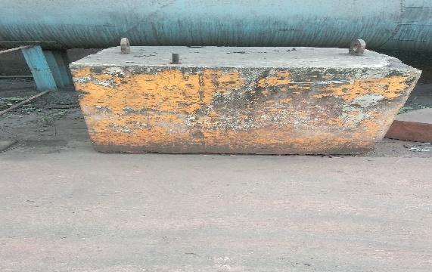 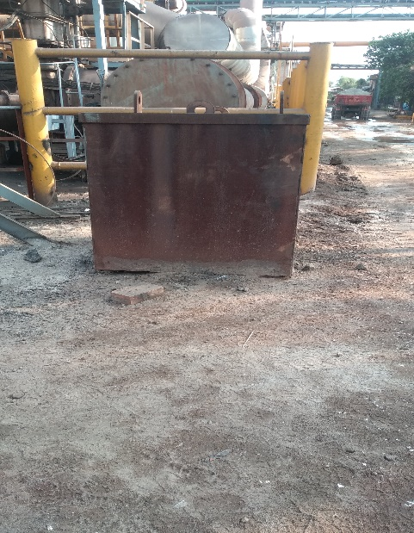

3 T 5T

Follow the below given criteria for the visual inspection of the other lifting tools and tackles

Inspection method and its criteria

(1) Wire rope sling

|  |  |  |  |
| --- | --- | --- | --- |
| Part to inspect | | Inspection method | Criteria |
| Wire rope | | 1. Check visually for number of broken wires in one lay.  2. Check a rope diameter for wear by a caliper.  3. Check visually for kink.  4. Check visually for deformation.  5. Check visually for rust or corrosion.  6. Check visually for deformation at eyes.  7. Check visually for looseness at eyes. | 1. Broken wires shall be less than 10 % of element wires in one lay.  2. The diameter decrease shall be less than 7 % of the nominal diameter.  3. No kink.  4. No marked deformation.  5. No marked rust or corrosion.  6. No marked deformation.  7. No looseness. |
| Inspection method and its criteria  (2) Chain sling   |  |  |  | | --- | --- | --- | | Part to inspect | Inspection method | Criteria | | Chain | 1. Check for elongation.    2. Check for the overall deformation and twist. | 1. The elongation in five links shall be less than 5 % of the original length.  2. No marked deformation or twist. | | Link | 1. Check the link diameter for wear.  2. Check for crack, deformation, twist or bend. | 1. The decrease of link diameter shall be less than 10 % of the original one.  2. No marked crack, deformation, twist, wear or bend. |   (3) Belt sling   |  |  |  | | --- | --- | --- | | Part to inspect | Inspection method | Criteria | | Belt | Check for damage (wear, flaw) | 1. Seams shall be clearly identified. No marked defect such as damaged warp, rough shag.  2. Flaws shall be less than one tenth of the belt width and one fifth of depth of the belt thickness.  3. In the case that the use limit is provided, the limit display does not remarkably appear or is not disappearing. | | Eyes | Check for damage (wear, flaw) | 1. Seams shall be clearly identified. No damaged warp.  2. No marked scratch, abrasion, etc.  3. The eye form is kept correctly, even if some of sewing thread is cut  4. No separation at sewn joint. | | Metal fitting | Check for damage (deformation, crack, corrosion) | 1. No deformation.  2. No marked damage by hitting, scratch.  3. No crack.  4. No marked corrosion. |   (4) Hook   |  |  |  | | --- | --- | --- | | Part to inspect | Inspection method | Criteria | | Hook | 1. Check for the opening throat  2. Check for the twist  3. Check for cracks | 1. The dimension of the opening throat shall be less than 5 % of the original opening.  2. No marked twist  3. No marked crack |   (5) Clamp   |  |  |  | | --- | --- | --- | | Part to inspect | Inspection method | Criteria | | External appearance and function | 1. Check for deformation and twist.  2. Check the function of a cam and lock for abnormality.  3. Check for crack, rust or arc strike. | 1. 1 No marked deformation or twist.  2. The cam and lock shall work correctly.  3. No crack, rust or arc strike. | | Cam and jaw | 1. 1 Check tooth for lack or wear.  2. Check for crack, rust. | 1. 1 The lack and wear of tooth shall be within the limit indicated by the manufacturer.  2. No crack or marked rust. | | Pins | 1. Check for bend.  2. Check for wear. | 1. No bend.  2. No marked wear. |   (6) Lifting hook   |  |  |  | | --- | --- | --- | | Part to inspect | Inspection method | Criteria | | Hook | 1. 1 Check for elongation, twist, opening, deformation of width.  2. Check for hit flaw, dullness and damage at hook point.  3. Check for crack. | 1. No elongation, twist, opening, deforma-tion.  2. No flaw, dullness or damage.  3. No marked crack.  4. UT and MPT test to be done annually | | Arc strike | Check for arc strike. | No arc strike |   (7) Shackle   |  |  |  | | --- | --- | --- | | Part to inspect | Inspection method | Criteria | | Body | 1. Check for opening, shortening, twist and wear.  2. Check for crack.  3. Check for wear and damage of screw by an eyebolt. | 1. No opening, shortening, twist or wear.    2. No crack.  3. No abnormality. | | Eyebolt, bolt and pin | Check for bent, crack and wear. | No bent, crack or wear. | | | | |
|  |  |  |  |  |

1. Follow procedure WI/MAINT/12 while handling the material.
2. Carry out housekeeping as per WI/MAINT/91 after completion of the job.
3. For EOT cranes & hoist check deflection as per IS 4137 and 807

**50 T Hot metal Crane Load Testing BF#1 & BF#2**

Place Empty ladle in Crane bay( Pic Attached) using Hitachi. Put cold pigs in empty ladle and lift using 50 T crane hook 1m above ground and

The Weight of empty ladle 10T.

Weight of pigs to be brought by truck after weighment and using wheel loaders load into ladle.

Before using empty ladle check healthiness of Empty ladle.

Once Load test has been done remove pigs by cutting open the ladle body.

Do not use hot metal for testing purpose

For EOT cranes & hoist check testing and deflection as per IS 4137 and 807.

Testing to be carried out during furnace shutdown and area to be barricaded

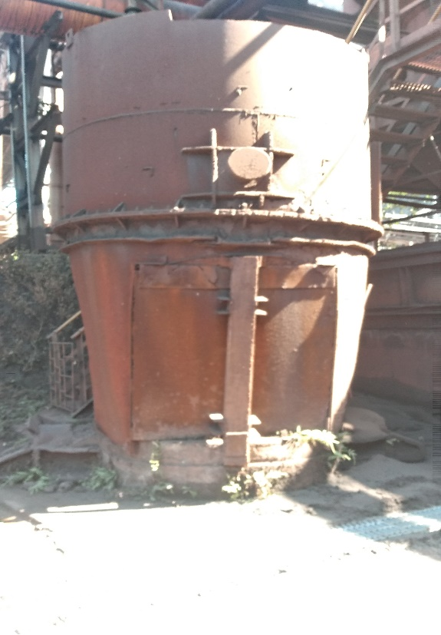

**Baghouse Crane:**

Place empty ladle in baghouse crane bay.

Ensure that the ladle is empty and cold.

Weight of pigs to be brought by truck after weighment and using wheel loaders load into ladle.

Before using empty ladle check healthiness of Empty ladle.

Once Load test has been done remove pigs by tilting the ladle using bag house crane.

For EOT cranes & hoist check testing and deflection as per IS 4137 and 807.

**Grab cranes**

For EOT cranes & hoist check testing and deflection as per IS 4137 and 807.

Remove grab bucket from the hoist by decamping wire ropes.

Move aside the grab bucket using hydra.

Place the counterweight and connect the hoisting wire rope on to the counterweight using Bull dog clamps.

Lift the counter weight 1m above ground and do Long travel. Deflections to be measured as per IS4137

Ensure that Slag pit is empty. LOTO taken for Slag granulation pumps. & furnace is in Shutdown while carrying out the Activity.

Below Counter weight to be used for doing load test on grab cranes.

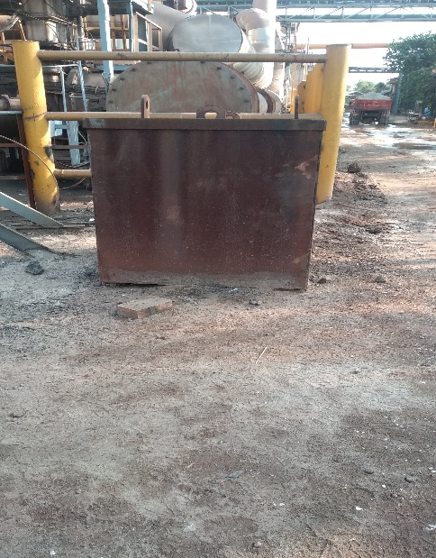

5T

**Work No:6 : SAFETY, CERTIFICATION AND INSPECTION OF LADDER FOR SAFE WORKING**

**WORK NO A: SAFE USE OF LADDERS AND STEP LADDERS**

1. Inspection of the ladder has to be done at the start of the job. Check the certification date on tag pasted at the height of 1.5 mts from the bottom on the rail.
2. Use ladder in one position for a maximum of 30 minutes to reduce stress on person working.
3. Use ladders for ‘light work’ - they are not suitable for strenuous or heavy work.
4. Use ladders having rubber shoes at both ends
5. Use ladder where you can maintain three points of contact (hands and feet) at the working position
6. keep your belt buckle (navel) inside the stiles and both feet on the same rung throughout the task (refer fig 1b)



1. When working on stepladders you should avoid work that imposes a side loading, such as side-on drilling (through bricks or concrete) refer fig 2a &2b



1. Safe ground slopes on a suitable surface (unless the manufacturer states otherwise) are as follows:

* Side slope - 16 deg ,
* back slope – 6 deg

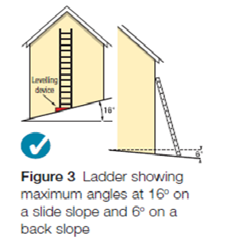

1. Use ladder on clean, solid surfaces (paving slabs, floors etc). These need to be clean (no oil, moss or leaf litter) and free of loose material (sand, packaging materials etc) so the feet can grip. Shiny floor surfaces can be slippery even without contamination
2. Only one person must climb on the ladder at any given time.
3. Ladders to be put up at the correct angle of 75deg. To judge the angle use the angle indicator marked on the stiles of some ladders or the 1 in 4 rule (1 unit out for every 4 units up, as shown in Figure 10);

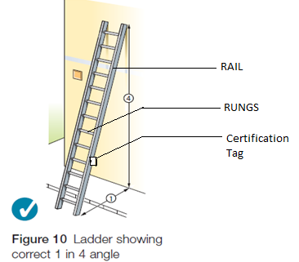

1. Use ladder where they will not be struck by vehicles, by protecting them with suitable barriers or cones.
2. Use stepladders where the restraint devices can be fully opened. Any locking devices must also be engaged
3. Use ladder where they will not be pushed over by other hazards such as doors or windows, by securing doors (not fire exits) and windows where possible. If this is impractical, have a person standing guard at a doorway, or inform workers not to open windows until they are told to do so.
4. Use ladder where pedestrians are prevented from walking under them.
5. Do not work within 6 m horizontally of any overhead power lines, unless the power line is made dead or protected with temporary insulation. If this is a regular activity, find out if the lines can be moved.
6. Always use a non-conductive ladder or steps for any necessary electrical work.
7. Only use ladders or stepladders that have no visible defects. User should have a pre-use check each working day.
8. Inspect the rungs, cleats and steps for safe use. They shall be parallel, level and uniformly placed.
9. Ladders used for access should project at least 1 m above the landing point and be tied.
10. The user must wear robust, sensible footwear (e.g. safety shoes/boots or trainers). Shoes should not have the soles hanging off, have long or dangling laces, or be thick with mud or other slippery contaminants
11. User needs to be fit - certain medical conditions or medication, alcohol or drug abuse could stop them from using ladders. If you are in any doubt, speak to an occupational health professional

**On a ladder or stepladder**

**DONT’S**

* Do not use ladders that have been exposed to fire or corrosive chemicals.
* Do not use a ladder for unintended purposes, such as in place of scaffolding.
* Never allow more than one person on a ladder at a time.
* Workers should never work with one leg on a ladder and one off.
* Don’t work within 6 m horizontally of any overhead power lines
* Impose a side loading, such as side-on drilling through solid materials (eg bricks or concrete),
* Rest ladders against weak upper surfaces (eg. glazing or plastic gutters).
* Move them while standing on the rungs/steps
* Don’t use the top three rungs of ladder and top two rungs of step ladder (ref fig 9 &11)
* Use them in strong or gusting winds
* Stand them on moveable objects, such as pallets, bricks, lift trucks, tower scaffolds, excavator buckets, vans, or mobile elevating work platforms
* Never fasten two ladders to create longer section
* Do not use cross bracing on a stepladder for climbing
* Do not use ladders that have been exposed to fire or corrosive chemicals.
* Do not use a ladder for unintended purposes, such as in place of scaffolding.
* Never allow more than one person on a ladder at a time.
* Don’t set ladders where they may be hit or dislodged.

**DO’s**

* Use ladder on firm ground or spread the load (e.g. use a board)
* Use ladder on level ground - for stepladders refer to the manufacturer’s instructions
* Use ladder on clean, solid surfaces.
* Use certified ladders only
* Use slip resistant shoes.
* Use both hands to climb a ladder.
* Always face the ladder when climbing, descending or working.
* Avoid the top two steps of a stepladder and the top four rungs on other ladders.
* When working to the side, maintain balance.

Fig. Shows -Three clear rungs for ladder and two clear rungs for step ladder  

**SAFE STEP LADDER USAGE**

1. **Always face the ladder**
2. **Stay off top two steps.**

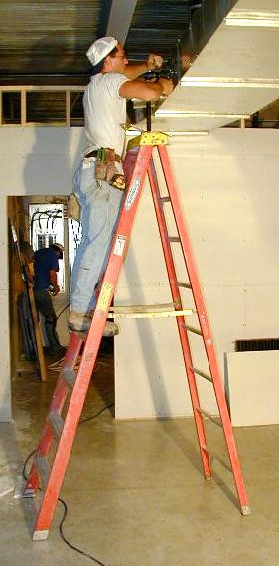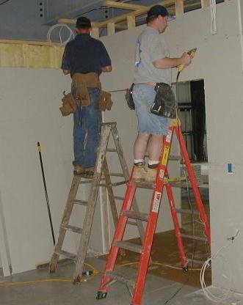

1. When working to the side, maintain balance.

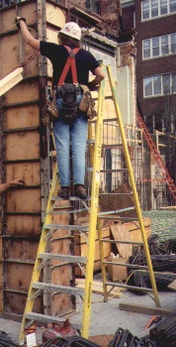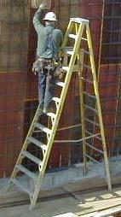

**LADDER ACCESS**

* **These are a very poor and hazardous set ups!**
* **Many workers fall from ladders while accessing to another work area.**

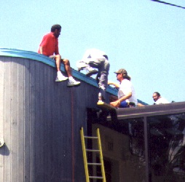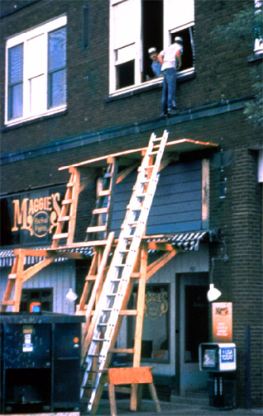

**NO!**

**Work No B: Certification & Inspection of Ladder**

1. Carry out certification and inspection of the ladder as per the checklist/guidelines given below.

* Check the side rails to be free from cracks, dents, bends and blemishes
* Rungs must be tight, intact and free from grease or oil.
* Check whether the spreader arms are tight and move freely
* Make sure there are no splinters or sharp edges.
* See that metal ladders are not dented or bent.
* Safety feet should be in place and look for wear or loose rivets.
* Check all support braces and bolts are present and secure.
* On extension ladders, make sure rope is not torn or frayed.
* On stepladders, make sure the hinge spreader is working properly.

1. Certify the ladder by sticking new label with renewed dates at height of 1.5 meter on rails from bottom, if the ladder is as per our requirements and duly signed by the engineer in-charge.
2. If the ladder is not as per requirement, request the concerned to remove the ladder from the service until the same is complied with safety requirements.
3. Inspection to be carried out at every 3-month.
4. Record to be maintained with status of ladder certified.

**LADDER INSPECTION FORM:**

|  |  |  |  |  |  |  |  |  |  |
| --- | --- | --- | --- | --- | --- | --- | --- | --- | --- |
| **LADDER INSPECTION FORM** | | | | | | | | | |
| **INSPECTOR :** | **DEPARTMENT:** | | | | | | | | |
| **DATE OF INSPECTION:** | **LADDER TYPE:** | | | | | | | | |
| **LADDER ID:** | **LOCATION:** | | | | | | | | |
|  | | | | | | | | | |
| **INSPECTION ITEM - GENERAL LADDER** | **DAMAGED** | **MISSING** | **WORN** | | **OK** | | **N/A** | | **REMARKS** |
| 1. SIDE RAILS - Free from cracks, dents, bends and blemishes |  |  |  | |  | |  | |  |
| 2. RUNGS/STEP – Ensure tightness and no rotation |  |  |  | |  | |  | |  |
| 3. FASTENERS – Rivets, nuts and bolts |  |  |  | |  | |  | |  |
| 4. FEET – Look for wear or loose rivets |  |  |  | |  | |  | |  |
| 5. Condition of rubber bushes |  |  |  | |  | |  | |  |
|  | | | | | | | | | |
| **STEP LADDER** | **DAMAGED`** | **MISSING** | **WORN** | **OK** | | **N/A** | | **REMARKS** | |
| 1. TOP CAP - Free from cracks and dents |  |  |  |  | |  | |  | |
| 2. SPREADER ARMS – Tight and move freely |  |  |  |  | |  | |  | |
| 3. HORIZONTAL BRACES- Ensure tightness |  |  |  |  | |  | |  | |
| 4. STEP BRACES - Ensure tightness |  |  |  |  | |  | |  | |
| 5. PAIL TRAY – Moves freely, is tight and sets up properly |  |  |  |  | |  | |  | |
|  | | | | | | | | | |
| **EXTENSION & TOWER LADDER** | **DAMAGED`** | **MISSING** | **WORN** | **OK** | | **N/A** | | **REMARKS** | |
| 1. END CAPS – Tight and free from cracks, chips or wear |  |  |  |  | |  | |  | |
| 2. ROPE AND PULLEY – Checking of wire rope |  |  |  |  | |  | |  | |
| 3. GRAVITY LOCKS – Ensure they pivot freely and in good condition |  |  |  |  | |  | |  | |
| 4. SLIDE GUIDES – Free from cracks, chips and, wear |  |  |  |  | |  | |  | |
| 5. BASE AND FLY SECTION – Ensure they are tight and not wrapped |  |  |  |  | |  | |  | |

IT IS THE RESPONSIBILITY OF THE USER TO MAINTAIN THE SAFETY EQUIPMENTS / PERSONNEL PROTECTIVE EQUIPMENT IN GOOD CONDITION. IF ANY DESCRIPANCY NOTED IN THE SAME TO BE RECTIFIED IMMEDIATELY OR TO BE RETURN BACK THE SAME TO STORE AS SCRAP.

Don’t :

Use mobile phone

**Amendement Record**

|  |  |  |  |
| --- | --- | --- | --- |
| **Date** | **Manual Section Ref. & Para** | **Brief details of Revision** | **New Rev.** |
|  |  |  |  |
|  |  |  |  |
|  |  |  |  |

|  |  |  |
| --- | --- | --- |
| **Prepared By:**  Area Engineer | **Reviewed & Issued By:**  Management Representative | **Approved By:**  Mechanical Head |
| **Signature** | **Signature:** | **Signature:** |
| **Review Date: 12.12.22** | **Review Date: 12.12.22** | **Review Date: 12.12.22** |